Andrew Makowski

10/17/2023

Deep Learning Challenge Report

Overview:

Alphabet Soup wants to create an algorithm to predict whether applicants for funding will be successful. With knowledge of machine learning and neural networks using the features in the provided dataset to create a binary classifier that is capable of predicting whether applicants will be successful if funded.

Results:

* Data Preprocessing
  + What variable(s) are the target(s) for your model?

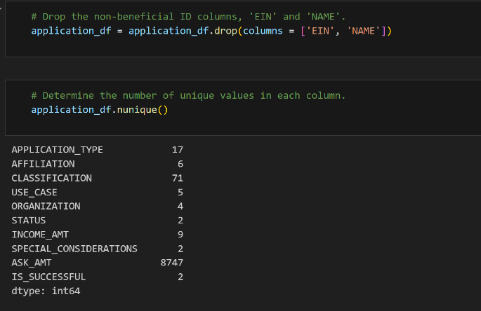

* + What variable(s) are the features for your model?

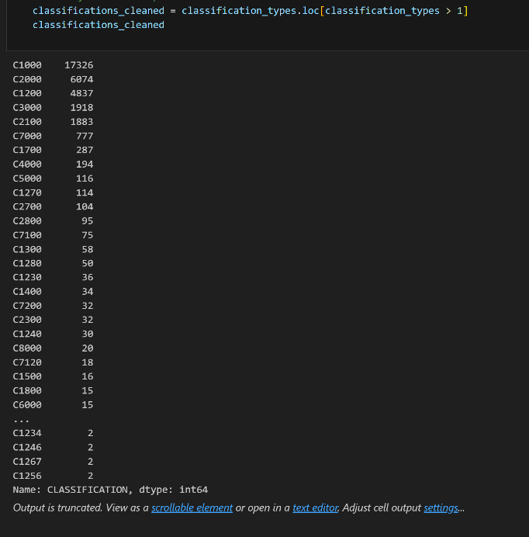

* + What variable(s) should be removed from the input data because they are neither targets nor features?

I think the EIN column are the ones that should be removed

* Compiling, Training, and Evaluating the Model
  + How many neurons, layers, and activation functions did you select for your neural network model, and why?

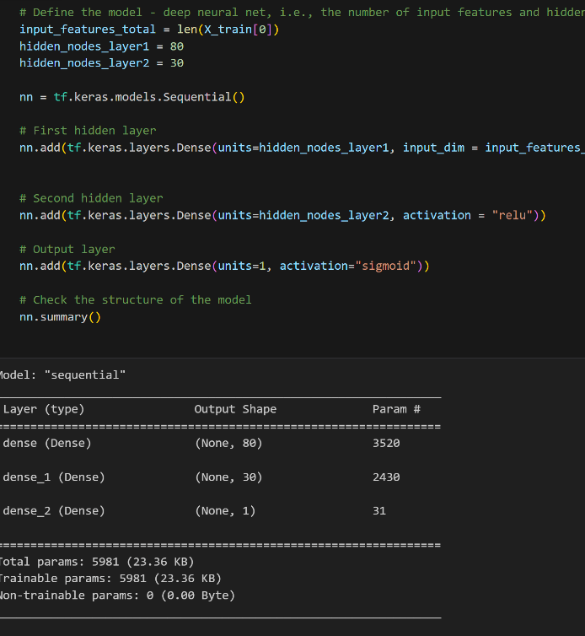

* + Were you able to achieve the target model’s performance?

Yes, I was able to get 72% in the first model and 75% in the second.

* + What steps did you take in your attempts to increase model performance?

In the second model I was able to I add the columns NAME to the application_df then set a bin to the Name columns to reach the available accuracy of 75%

Summary:

In the first model I was able to get the most accurate